1. How are the project sponsors financing this deal? How does the financing of the Field System differ from the financing of the export system?

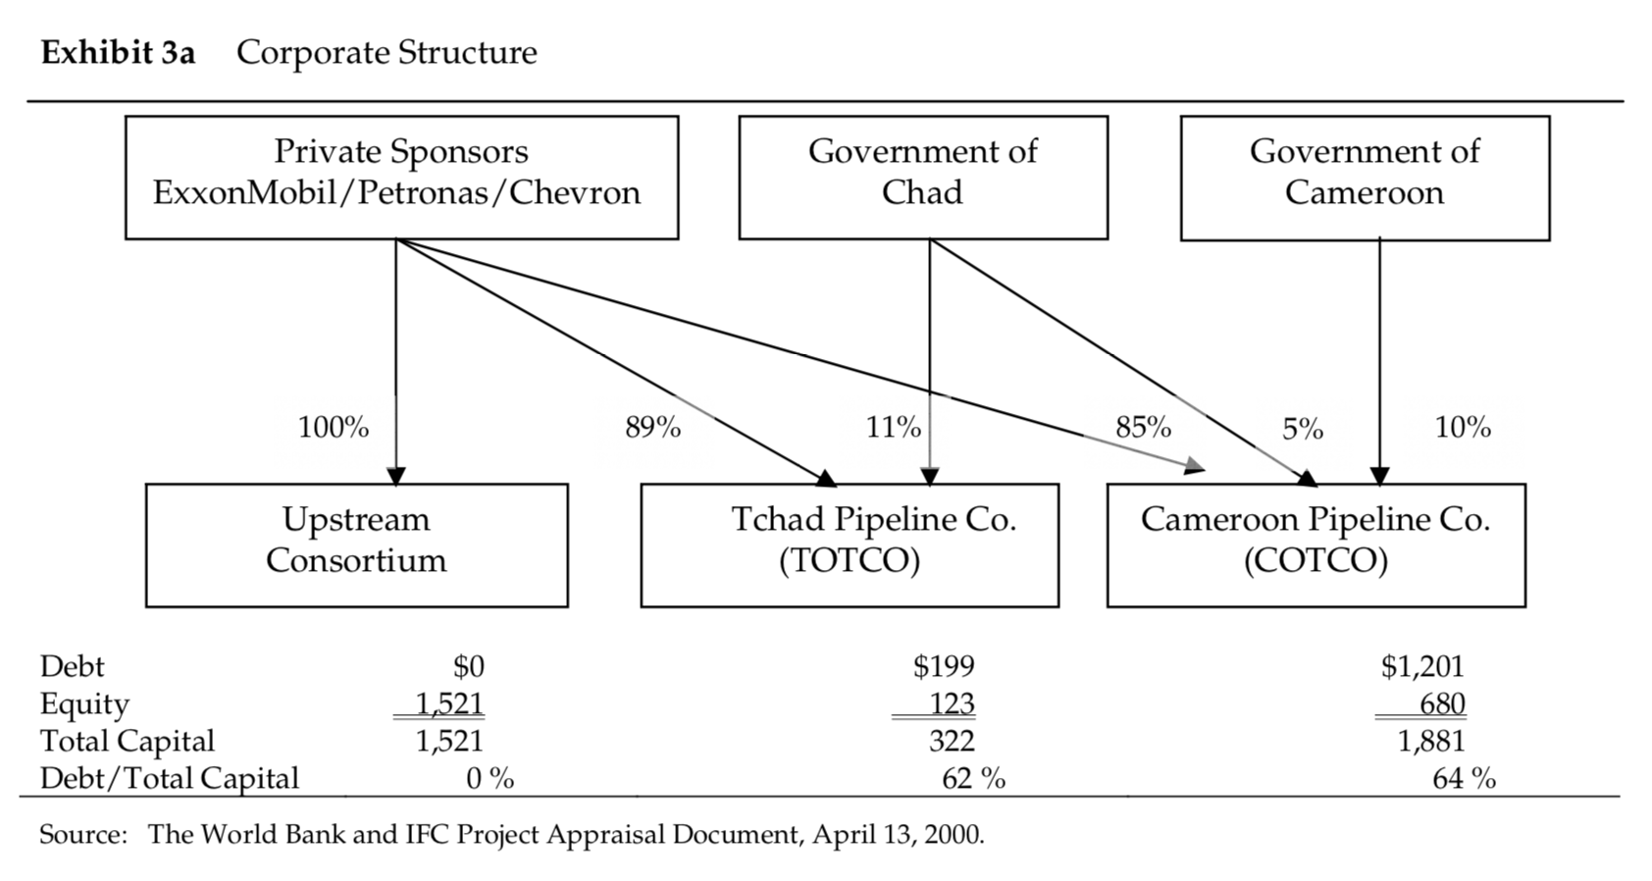

The proposed structure included $2.3 billion of equity. Of which $2.2 billion comes from private sponsor.$1.4 billion was financed through debt.

Field system: use of corporate finance in project. No interest rate for investment loan.

Export system: Use of project finance in project. Interest for loans up to 7%. High insurance prime associated with offshore.

1. What are the risks and returns for a) Chad b) Cameroon, and c) Private Sponsors?

: For risks, there are political risks, price risk, reserve risk and construction risk. As both Chad and Cameroon are suffering from corrupted governments and civil wars, it is likely for the development or exploration to be halted at any moment. Also, as seen on the return table below, the price and reserve(possible production) range is massive, making the projected revenue not too reliable. Another risk is regarding construction of the infrastructure. Since both countries lack basic infrastructure, such as stable supply of electricity and railways it is possible for the construction of exploration spots to take longer than expected.

The table on the next page shows the respective IRRs for three parties, Chad, Cameroon, and Private sponsors. Except for the situation when the reserves are low and price is in the worst case, the IRR seems to be higher than cost of capital for all parties, indicating the viability of the project.

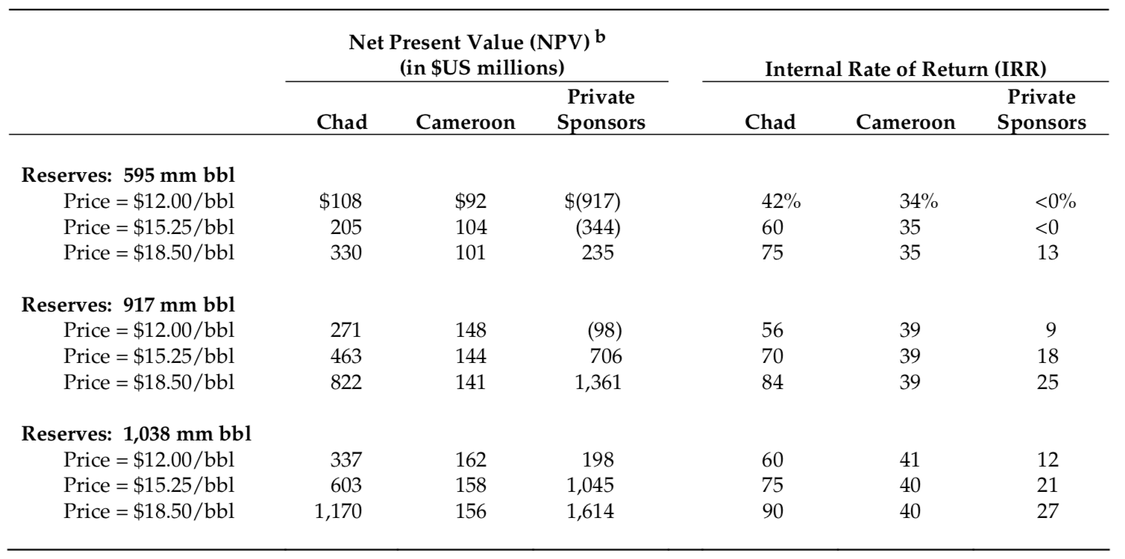

1. What aspects of the Revenue Management program would you change?
2. How to use income tax revenues should be regulated and limited for the Chad government, especially the money that can not be used for military expenses.
3. Royalties and dividends would be held in a Special Petroleum Revenue Account

The current version was listed.

10% saved for future generations

76.5% goes to development programs

13.5% goes to government programs in the oil producing region.

The three parts should be specified into more detailed sections.

1. Would you approve the deal as a World Bank/IFC board member?

: We would approve this deal based on the following reasons.

1. The people of Chad need help and Chad has few other options for development. This aligns with World Bank/IFC’s mission and with other (financially and operationally) reliable partners such as Exxon and Chevron involved, the risk for the project is mitigated.
2. Project shows positive NPV. It is uncertain which scenario in terms of price and reserve would become real, but overall the project has positive NPVs. This indicates financial viability of the project.
3. Social and environmental risks have been rigorously studied
4. The World Bank knows how to structure deals for success. With the organization’s multiple experiences in Africa, the World Bank can gain confidence in the investment.
5. The RMP will work, and Chad has shown several signs of “good faith”